**Winter 19.1**

19.1 - https://login.salesforce.com/packaging/installPackage.apexp?p0=04t0B0000001dzU

19.1 - https://test.salesforce.com/packaging/installPackage.apexp?p0=04t0B0000001dzU

1. Jira #22

⁃ ‘sydivaddr__c

- ‘sydivaddr_type__c

⁃ New Picklist Value

⁃ ‘Remit Address

⁃ Edit Picklist Value

⁃ Change ‘Label’ field on “Both” pick list value to “All

2. Jira #1491

⁃ ‘sydefault__c

⁃ Change page layout assignment to version 22

3. Ticket #24099

⁃ ‘syusr__c

⁃ New Picklist Values

⁃ ‘syusr_expsfustartopt__c

⁃ ‘Clock-On and Clock-Off

⁃ ‘syusr_sfustartopt__c

⁃ ‘Clock-On and Clock-Off

4. Ticket #24756

⁃ ‘icitem__c

⁃ De-activate Validation Rule

⁃ ‘Yield_Validation

5. Jira #781

⁃ ‘**rstk.ScriptExecutor.execute('set_sohdr_sumppy', true);**

**Winter 19.3**

19.3.1 - https://login.salesforce.com/packaging/installPackage.apexp?p0=04t0B000000MjC9

19.3.1 - https://test.salesforce.com/packaging/installPackage.apexp?p0=04t0B000000MjC9

1. Jira #628

- sydata_c.object

- New Picklist Values

- ‘sydata_txntype__c

- ‘Sales Order Pack Reversal

Sales Order Pick(Issue) Reversal

Sales Order Pick-Pack Reversal

Sales Order Pick-Pack-Ship Reversal

Sales Order Shipment Reversal

**Winter 19.4**

19.4 - https://login.salesforce.com/packaging/installPackage.apexp?p0=04t0B0000001fJi

19.4 - https://test.salesforce.com/packaging/installPackage.apexp?p0=04t0B0000001fJi

**Winter 19.5**

19.5 - https://login.salesforce.com/packaging/installPackage.apexp?p0=04t0B0000001fKg

19.5 - https://login.salesforce.com/packaging/installPackage.apexp?p0=04t0B0000001fKg

**Winter 19.6**

19.6.2 - https://login.salesforce.com/packaging/installPackage.apexp?p0=04t0B0000001fNz

19.6.2 - https://test.salesforce.com/packaging/installPackage.apexp?p0=04t0B0000001fNz

1. Jira #1790

- ‘sydefault__c

- Change page layout assignment to version 23

2. Jira #1886

- ‘soinvline__c

- Delete Field

- ‘Tracking Number

3. Jira #1282

- Run 1282_menu script

**Winter 19.7**

19.7 - https://login.salesforce.com/packaging/installPackage.apexp?p0=04t0B0000001fMN

19.7 - https://test.salesforce.com/packaging/installPackage.apexp?p0=04t0B0000001fMN

1. Jira #1863

- ‘sydata__c

- New Picklist value

- ‘sydata_txntype__c

- ‘Sales Order Pack-Ship Reversal

2. Jira #1901

Missing objecthelp pages

- Click ‘Edit’ when you pull up the object and change the ‘Context-Sensitive Help Setting’

- ‘gljed__c

- Change ‘Context-Sensitive Help Setting’ to objecthelp_gljed

- ‘icitemsiteproj__c

- Change ‘Context-Sensitive Help Setting’ to objecthelp_icitemsiteproj

- ‘pjprojwbs__c

- Change ‘Context-Sensitive Help Setting’ to objecthelp_pjprojwbs

- ‘poconttype__c

- Change ‘Context-Sensitive Help Setting’ to objecthelp_poconttype

- ‘poroute__c

- Change ‘Context-Sensitive Help Setting’ to objecthelp_poroute

- ‘portetype__c

- Change ‘Context-Sensitive Help Setting’ to objecthelp_portetype

- ‘poship__c

- Change ‘Context-Sensitive Help Setting’ to objecthelp_poship

- ‘sylimitd__c

- Change ‘Context-Sensitive Help Setting’ to objecthelp_sylimitd

- ‘sylimits__c

- Change ‘Context-Sensitive Help Setting’ to objecthelp_sylimits

- ‘syresult__c

- Change ‘Context-Sensitive Help Setting’ to objecthelp_syresult

- ‘syresultd

- Change ‘Context-Sensitive Help Setting’ to objecthelp_syresultd

3. Jira #1885

- Run Deletion Script

- ‘Delete [select id from rstk__helpsetup__c];

- Run new updated page help csv file

- Use Data Loader to ‘Insert’ the org with the new csv file (CSV file located in Technical Support Repository)

- Data object = Help (rstk_helpsetup__c)

- The ‘Name’ Field will have to be dragged down manually in the Auto-Match window.

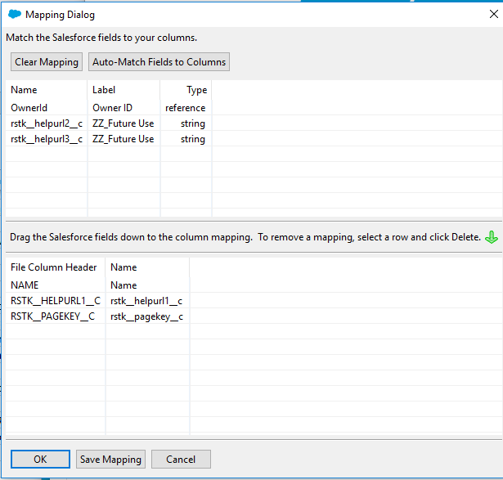

- Change all customer orgs SYCONFIG setting with new help fuel

- https://rootstock.force.com/Trailblazer/s/article/

4. Jira #2016

- Run 2016_menu script

5. Jira #1919

- Run 1919_menu

- Run 1919_menu_part2

6. Jira #1327

- Run 1327_menu script

**Winter 19.8**

19.8.1 – <https://login.salesforce.com/packaging/installPackage.apexp?p0=04t0B000000IZce>

19.8.1 – https://test.salesforce.com/packaging/installPackage.apexp?p0=04t0B000000IZce

1. Jira #2014
   1. Missing objecthelp pages

- Click ‘Edit’ when you pull up the object and change the ‘Context-Sensitive Help Setting’

- ‘obship__c or ‘Outbound Shipment

- Change ‘Context-Sensitive Help Setting’ to objecthelp_obship

- ‘obshipcont__c or ‘Outbound Shipment Container

- Change ‘Context-Sensitive Help Setting’ to objecthelp_obshipcont

- ‘icitemsite__c or ‘Inventory Item by Site

- Change ‘Context-Sensitive Help Setting’ to objecthelp_icitemsite

2. Jira #2158

a. Change page layout assignment

- ‘sydefault__c or ‘SYDEFAULT

- Change page layout to version 25

3. Jira #2201

a. Custom Setting

- Name = costrollup_MinCpuForIcitemstdSave

- Default Value = 2500

4. Jira #1119

a. Custom Setting

- Name = timeqtybooking_MaxNumberOfBookings

- Default Value = 8

- Description = Time & Qty Booking - Max number of bookings

5. Jira #2211

a. Template Change – Copy and paste ‘Packing Slip - MASTER - DO NOT MODIFY’ from dev-qa-ff

b. Overwrite customer’s existing Packing Slip template with the Master copy from dev-qa-ff only if RS-Support was last to modify template

- If customer modified template last then create a backup Packing Slip template named ‘Packing Slip BU’ with the changes from dev-qa-ff

**Winter 19.9**

19.9 - <https://login.salesforce.com/packaging/installPackage.apexp?p0=04t0B00000063l3>

19.9 - <https://test.salesforce.com/packaging/installPackage.apexp?p0=04t0B00000063l3>

**Winter 19.10**

19.10 - <https://login.salesforce.com/packaging/installPackage.apexp?p0=04t0B00000063mV>

19.10 - <https://test.salesforce.com/packaging/installPackage.apexp?p0=04t0B00000063mV>

1. Jira #2288 Summit Truck Bodies Only

a. New Custom Setting

Name = PLMItemProcessingLimit

Value = 100

Description = PLMItem Processing Limit

**Winter 19.11**

19.11.3 - <https://login.salesforce.com/packaging/installPackage.apexp?p0=04t4O000000MjEA>

19.11.3 - https://test.salesforce.com/packaging/installPackage.apexp?p0=04t4O000000MjEA

**Winter 19.13**

19.13 - <https://login.salesforce.com/packaging/installPackage.apexp?p0=04t4O000000QwCc>

* 1. - <https://test.salesforce.com/packaging/installPackage.apexp?p0=04t4O000000QwCc>

1. Jira #201
   1. ‘soamort__c
      1. Delete Validation Rule
         1. ‘Customer_can_not_change
   2. ‘sydata__c
      1. New Picklist Value
         1. ‘sydata_txntype__c
            1. ‘PO Receipt Reversal
2. Jira #2322
   1. ‘csusracctcntl__c
      1. New Picklist Values
         1. ‘csusracctcntl_txnid__c
            1. ‘CYCLECNT

INVLOCADJ